

FIRST SEMESTER 2020-2021

CE F213 SURVEYING

Digital Record

**Contour generation using Digital Elevation models and its applications**

**Exercise 1:** Download the DEM of your hometown from the website

<https://bhuvan.nrsc.gov.in/bhuvan_links.php> [Create login for downloading the data]

[Screen capture of your data here]

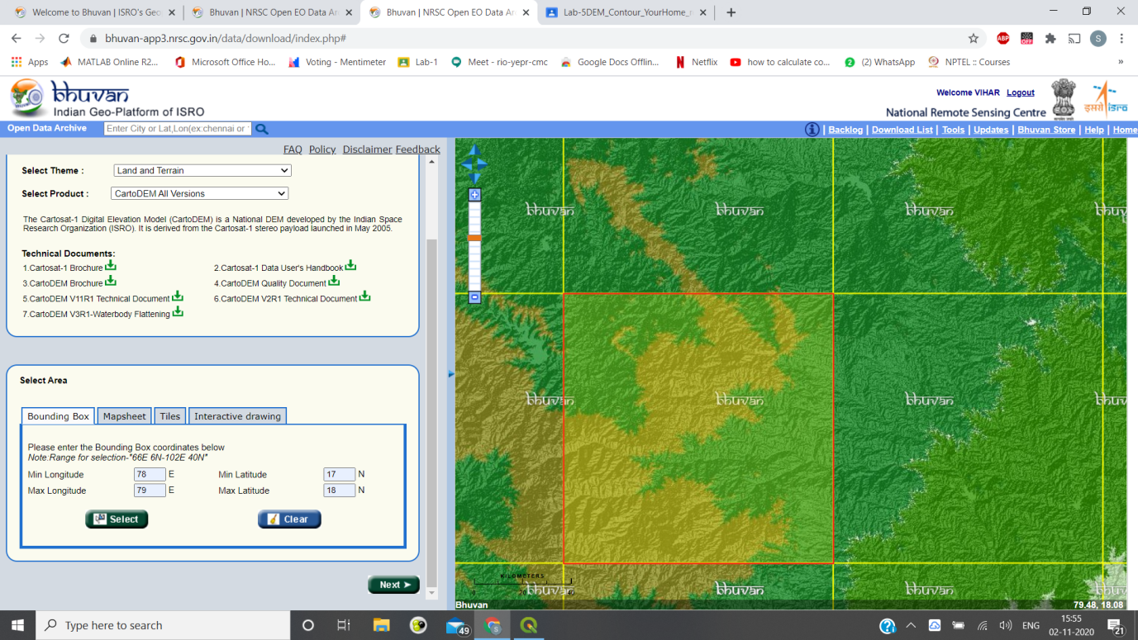

**Exercise 2:** Load the DEM in QGIS and add base map. Digitize a point corresponding to your house location and create a buffer [square type] of distance equal to 0.025 decimal degrees.

[Screen capture of buffer and point along with DEM displayed]

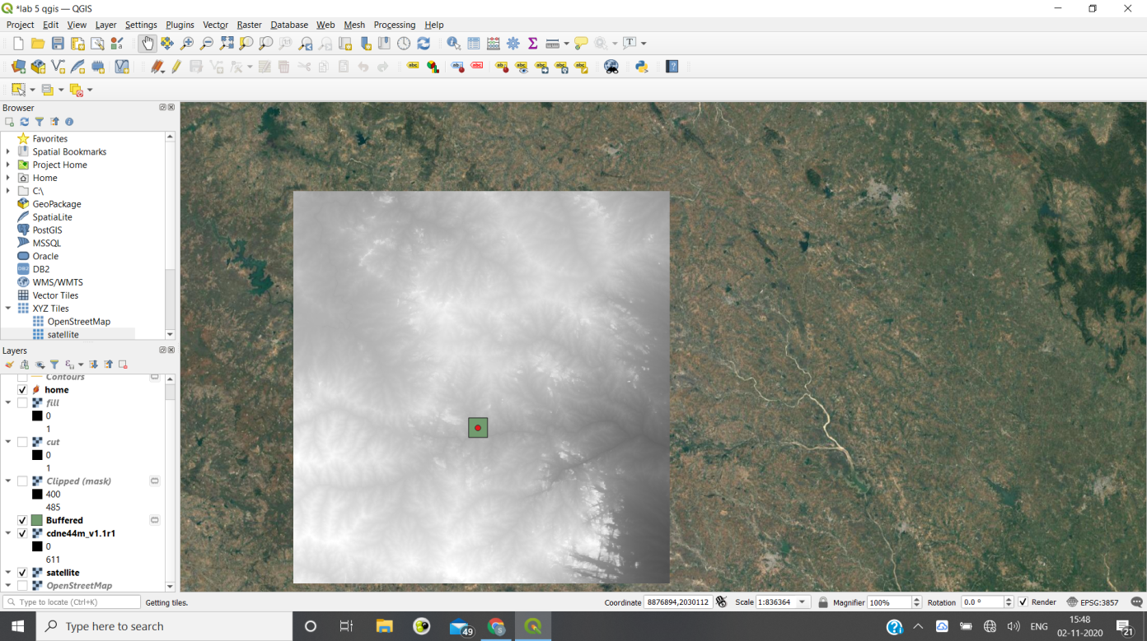

**Exercise 3:** Clip the DEM as per the created buffer

[Screen capture of Clipped DEM over base map]

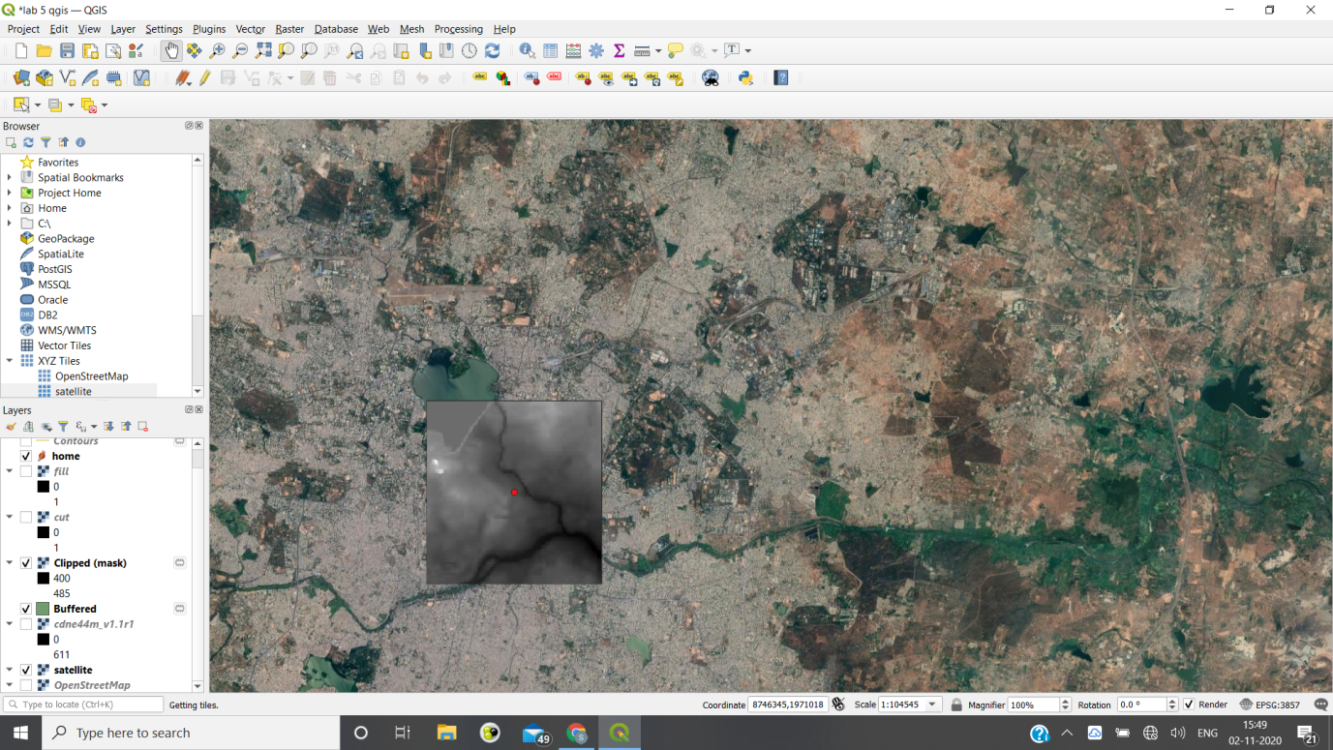

**Exercise 4:** Create a contour of 2m interval and 5 m interval and label the contours

[Screen capture of contour interval 2m and 5m]

2m

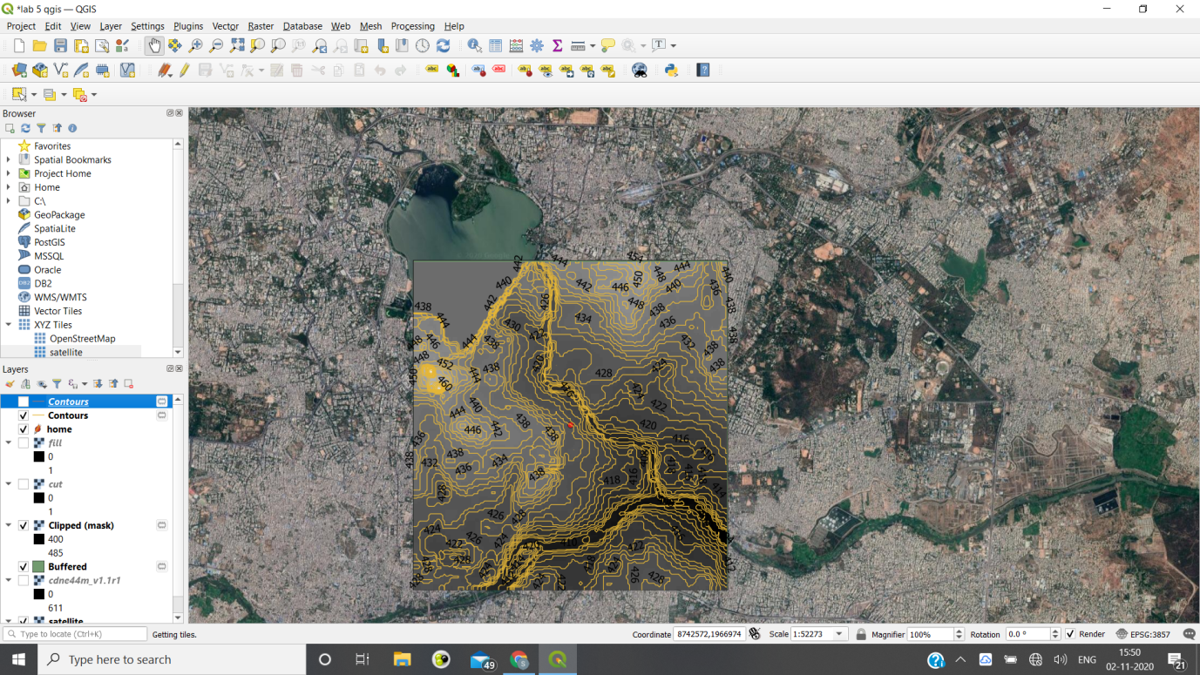

5m

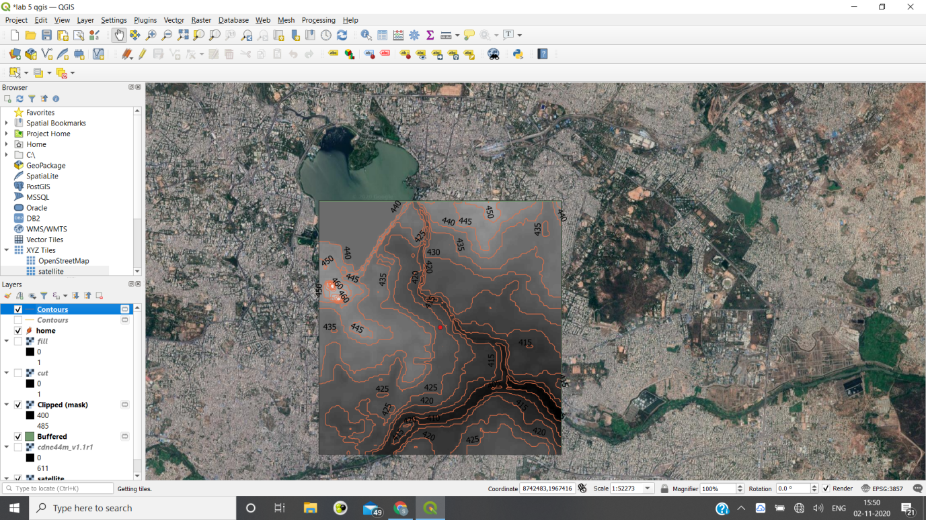

**Exercise-5:** Create cut and Fill image using DEM

Task-1: Find out the average elevation of the area using the given DEM

Write the average elevation of the DEM = --------------m

*Average Elevation of DEM=428.5484847539m*

Task-2: Create the cut layer and fill layer as per the average elevation

[Screen capture of cut layer and fill layer]

Cut

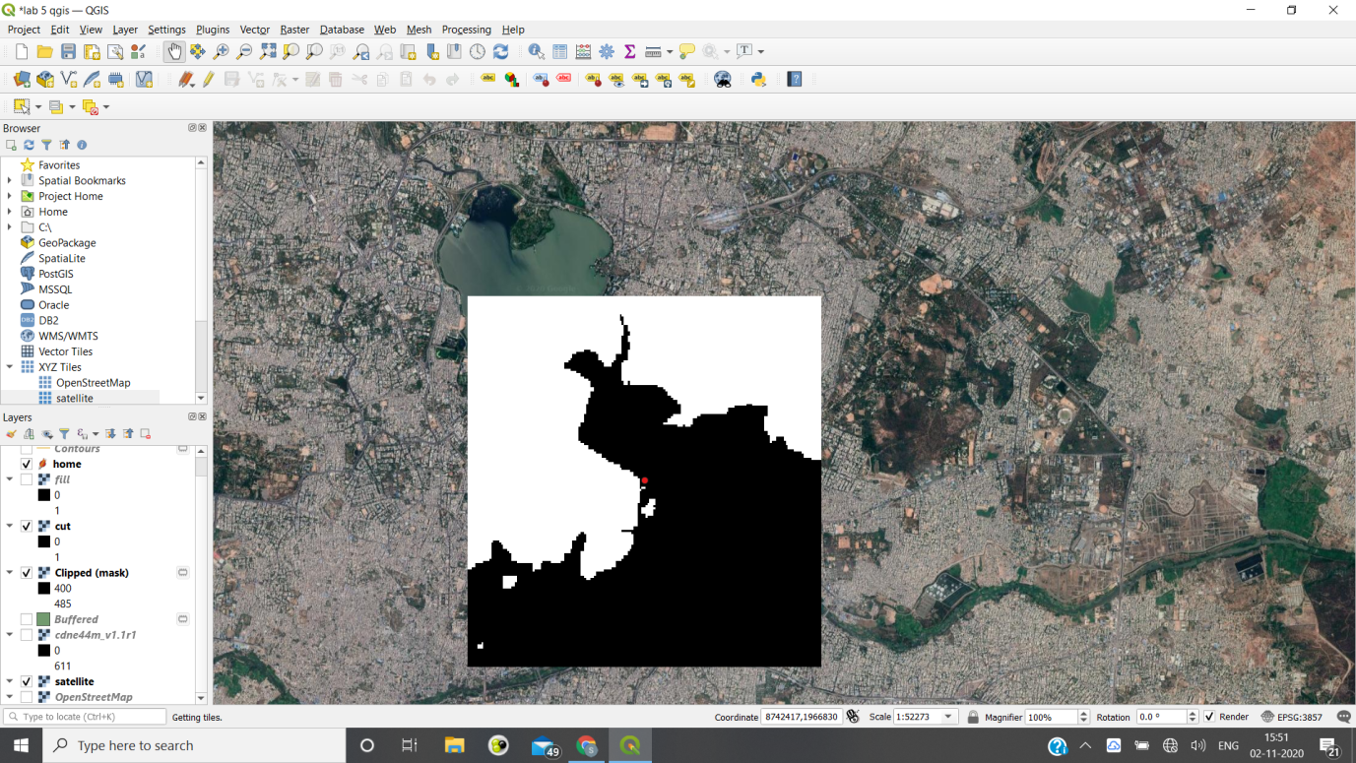

Fill

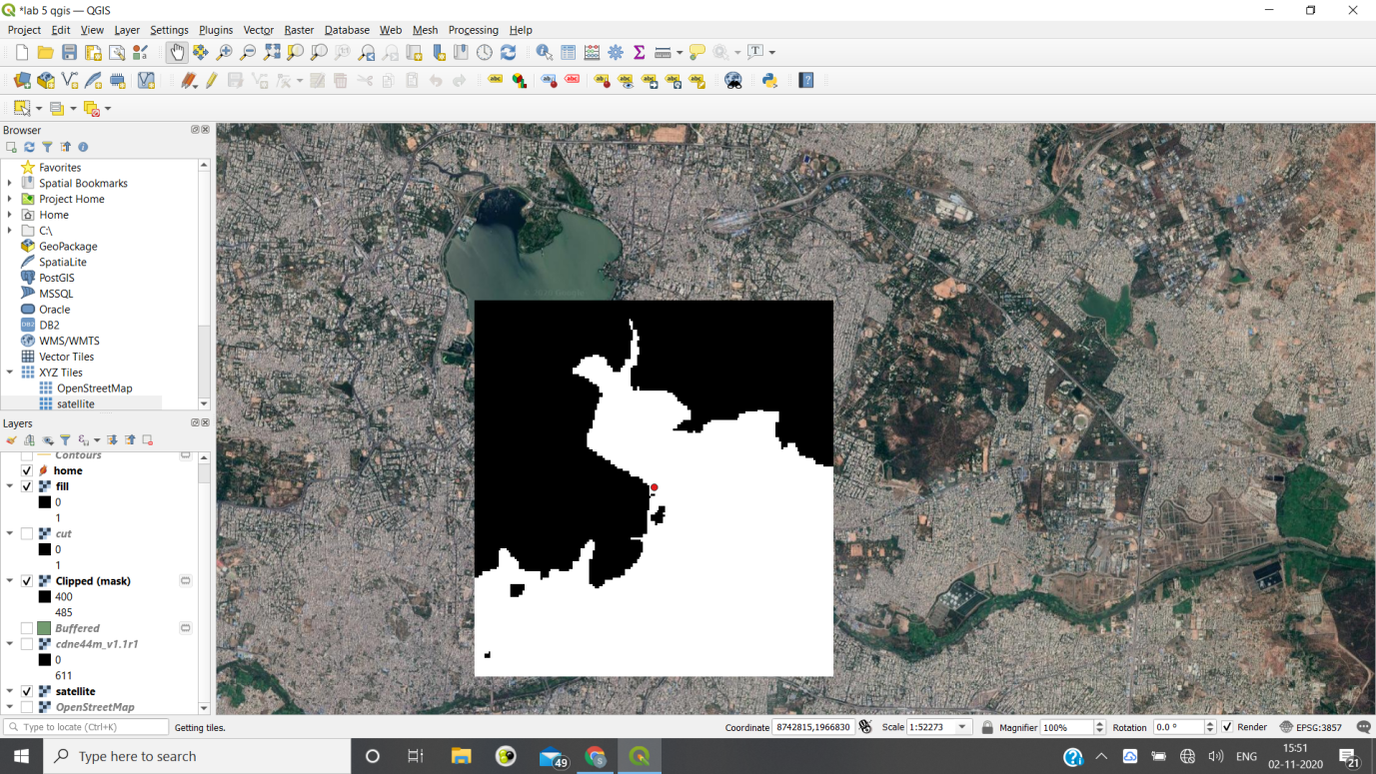

-------End of Exercise-------